

**Web Technologies**

**Assignment # 2**

**Project Report**

**Project Title :**

***Premium Clothing Brand Website* - *Aura***

**Group Members :**

|  |  |  |
| --- | --- | --- |
| Sr | Name | CMS |
| 1 | Aqib Raza | 461312 |
| 2 | Abdul Raheem | 469273 |
| 3 | Ahmad Raza | 465607 |
| 4 | Taimoor Safdar | 463920 |
| 5 | Meerab Chaudhary | 477284 |

**Introduction**

**Overview of the Project :**

This project presents a sleek and responsive e-commerce website for a premium fashion brand that emphasizes sustainability and innovation. Developed using **HTML5**, **CSS3**, **Bootstrap 5.3**, and **JavaScript**, the site offers a seamless user experience across all devices.

It showcases our ability to apply modern front-end development tools and design principles to create a well-structured, interactive web application tailored for a fashion-focused audience.

**Purpose :**

The aim of the website is to promote a high-end clothing brand with a strong commitment to eco-friendly values. It includes core pages such as **Home, Collections, About, Sustainability, and Contact** — each designed to be responsive and user-friendly.

**Features:**

Interactive features like **carousels, modals, offcanvas navigation**, and **tooltips** enhance usability, while JavaScript functionalities such as **theme toggling, scroll-to-top behavior**, and **custom form validation** add dynamic behavior and improve overall engagement.

Below is the detail of some of the basic **features** and **components** we have implemented so far:

**Advanced Bootstrap Components:**

**Carousel or Sliders:**

The **Featured Collections Carouse**l uses Bootstrap's carousel component with custom-styled navigation controls (***Previous/Next*** buttons). It automatically cycles through slides (***data-bs-ride="carousel"***) while allowing manual navigation via JavaScript-powered buttons (***data-bs-slide="prev/next"***). The controls include accessible labels (***aria-hidden***) and custom icons/text for enhanced UX

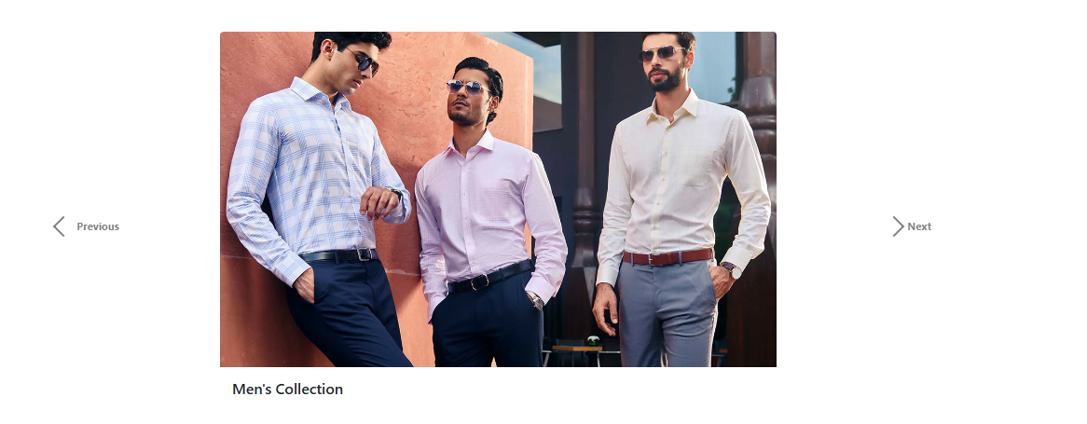

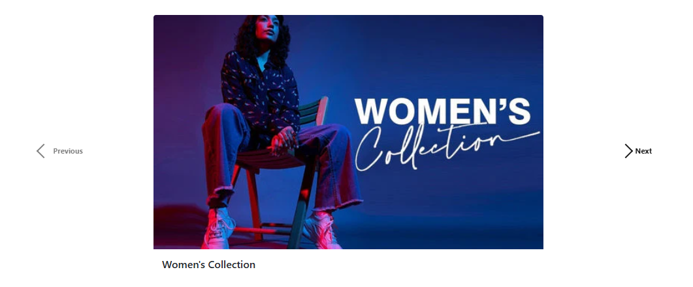

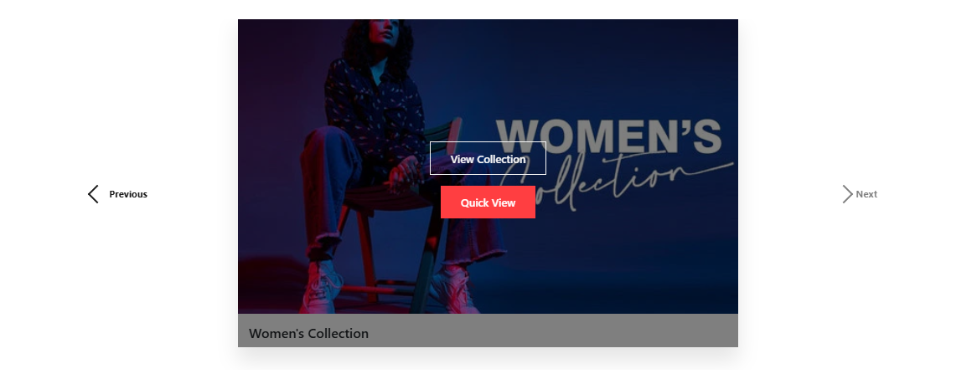

**Modals:**

The **Quick View** modal (triggered by product buttons) leverages Bootstrap's modal component with dynamic content loading via JavaScript, extracting product details (title, price, description, image) from ***data-\**** attributes and injecting them into the modal for a seamless, no-reload experience. It features responsive design, accessibility-compliant ARIA labels, and custom styling while fulfilling the assignment's requirements for both **Bootstrap components** (modals) and **JavaScript interactivity** (dynamic content).

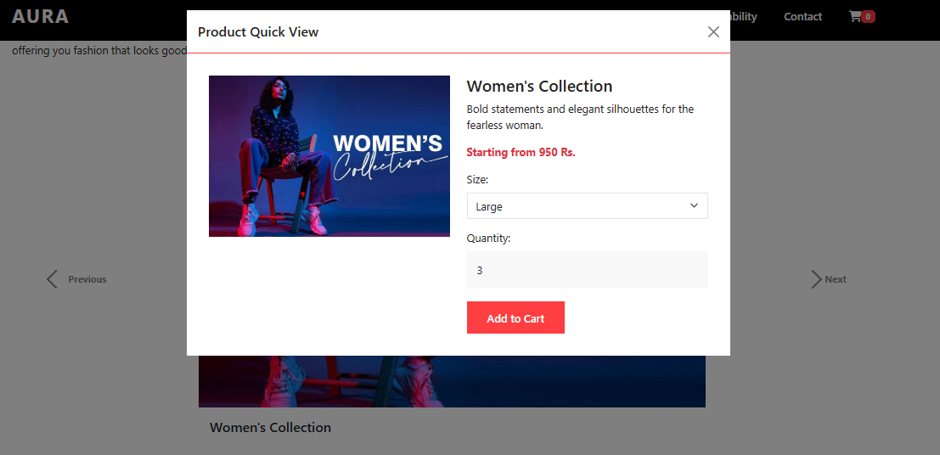

**Offcanvas Sidebar:**

Implemented using Bootstrap’s **offcanvas** component, the shopping cart slides in from

the right when the cart icon is clicked. It features **dynamic content loading** (via ***cart.js***),real-time price calculations, and a responsive design



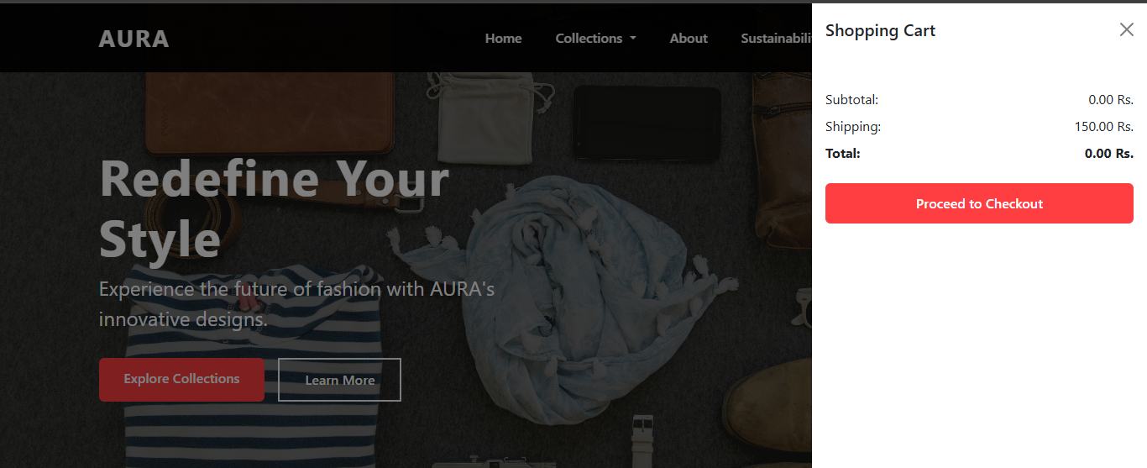

**Accordions:**

The FAQ section uses Bootstrap’s **accordion component** to create a collapsible Q&A interface. Each question toggles its answer via ***data-bs-toggle="collapse"***, ensuring a clean, space-efficient layout.

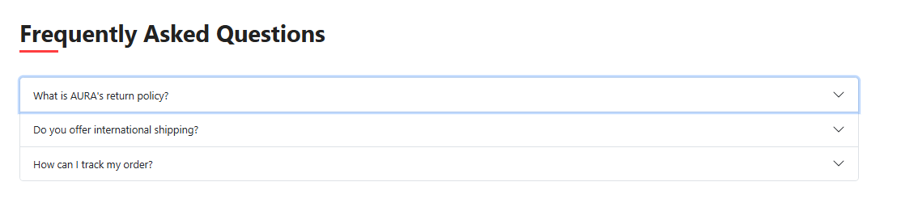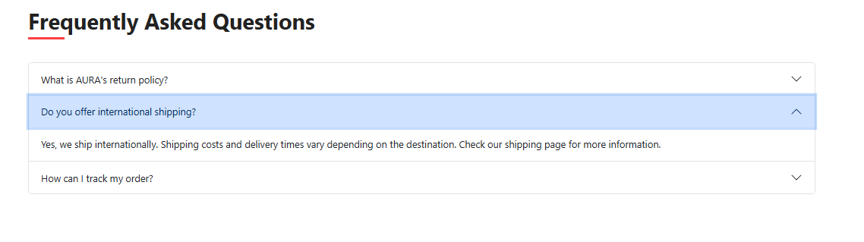

**Tooltips :**

Tooltips are implemented on social media icons (e.g., Facebook, Instagram) using Bootstrap’s ***data-bs-toggle="tooltip"***. The JavaScript initializes them on page load, displaying hoverable text (e.g., "*Follow us on Facebook*").

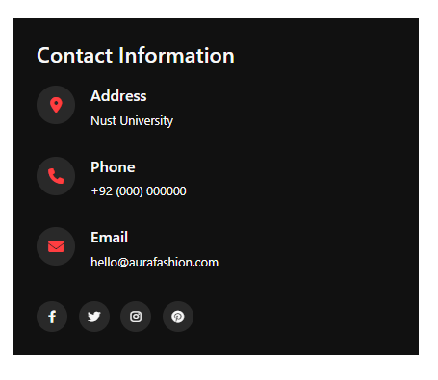

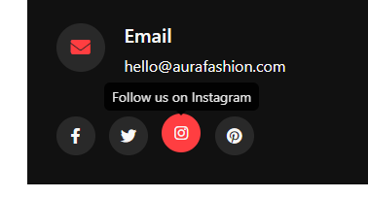

**JavaScript-Based Behavior Control**

**A dynamic theme switcher:**

The JavaScript-powered theme switcher toggles between light/dark modes (via ***darkMode.js***) using **classList** and **localStorage** to save preferences. The toggle button (fixed at bottom-right) dynamically updates its icon (***sun/moon***) and modifies all page elements, including accordions, through **DOM manipulation**. Event listeners enable real-time switching, while CSS variables ensure consistent styling.the toggle icon appears on bottom right corner of screen

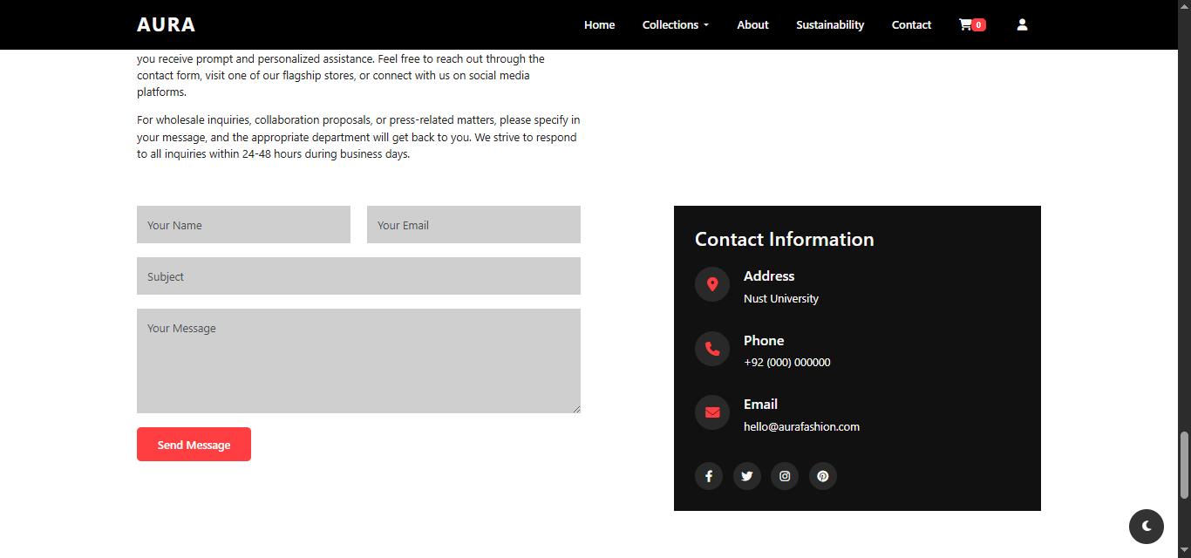

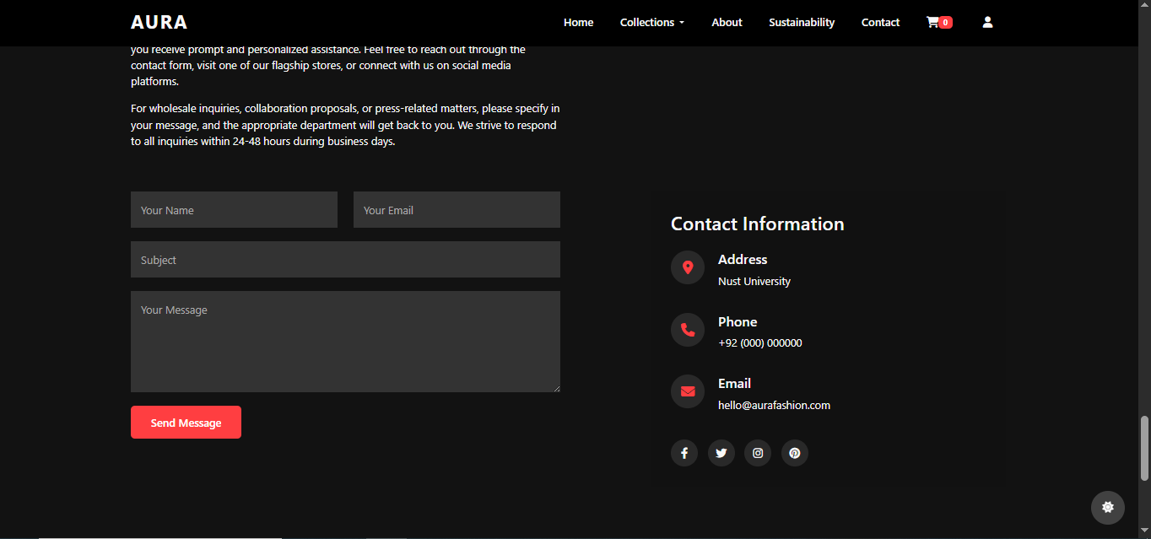

**A form validation script:**

The JavaScript system validates user registration with password complexity checks (*length, cases, numbers, special chars*) and email uniqueness via **localStorage**. The **registerUser()** and **loginUser()** functions handle data storage and authentication, while **setUserSession()** manages secure sessions.

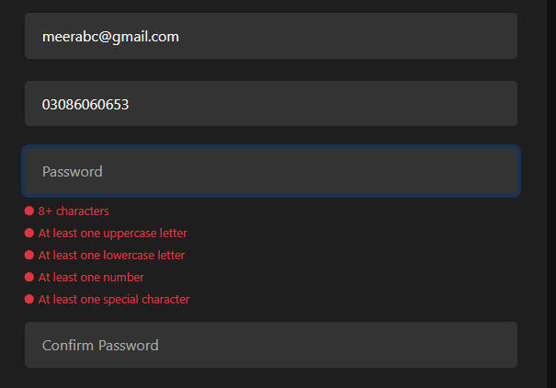

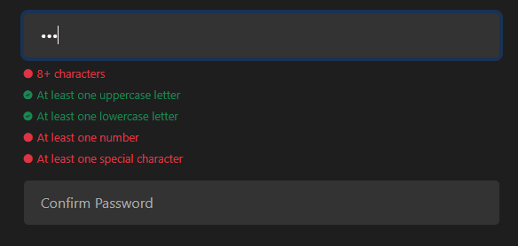

**A dynamic content loader:**

The **"Quick View"** button dynamically loads product details (*title, price, description, image*) into a Bootstrap modal using JavaScript (via ***modalfunctionality.js***). When clicked, it extracts data from ***data-\**** attributes of the triggering button (*data-product-title, data-product-price, etc*.) and populates the modal content. This meets the requirement for JavaScript-based dynamic content loading and enhances user experience by eliminating page reloads.



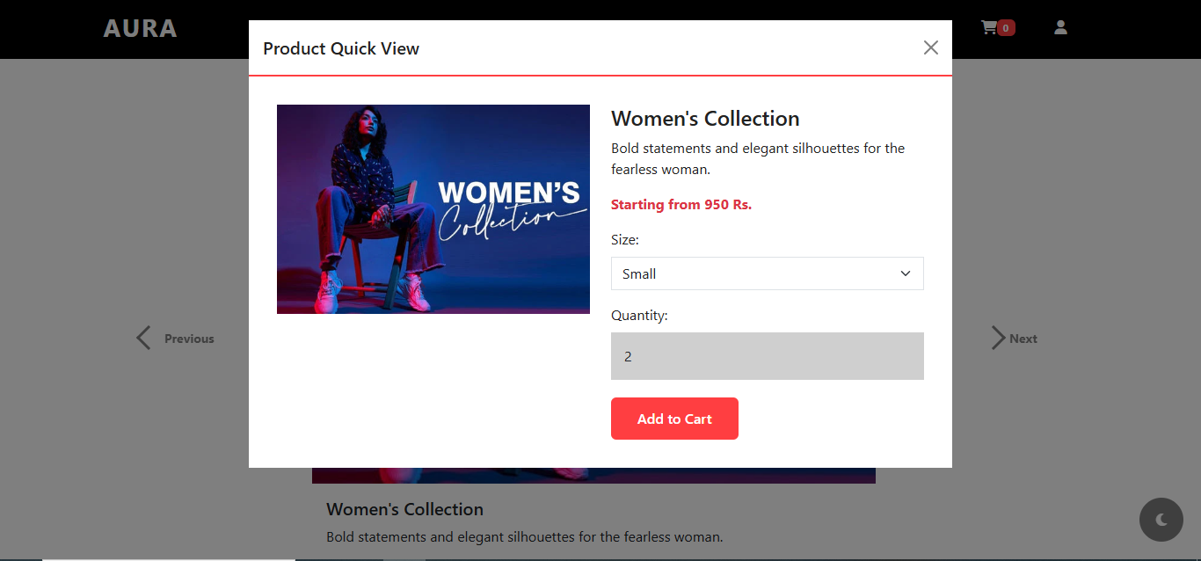

**A click-to-expand section for FAQs or product descriptions:**

The FAQ section uses Bootstrap's built-in **accordion component** (***data-bs-toggle="collapse"***) to create expandable/collapsible Q&A items. Each question toggles its answer when clicked, managed entirely by Bootstrap's JavaScript without custom code. This meets the requirement for interactive UI elements while maintaining accessibility (***aria-expanded, aria-controls***).



**Forms & Interactive UI Enhancements**

**Bootstrap Forms Implementation :**

**Contact Form (index.html)**: Collects user inquiries with fields for name, email, subject, and message.

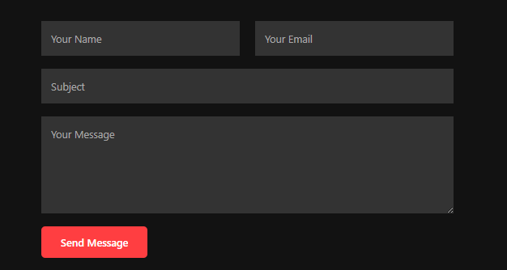

**Login Form (login.html):** Validates email/password via auth.js and login.js, with "Remember Me" option using localStorage/sessionStorage.

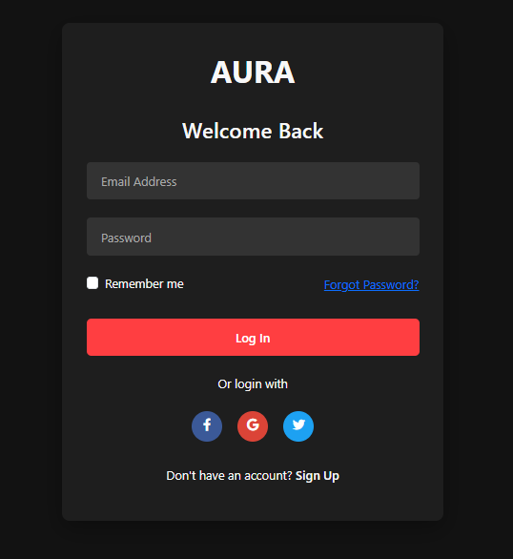

**Signup Form (signup.html):** Features live password validation (length, cases, numbers, special chars) via passwordValidator.js and stores data via auth.js.

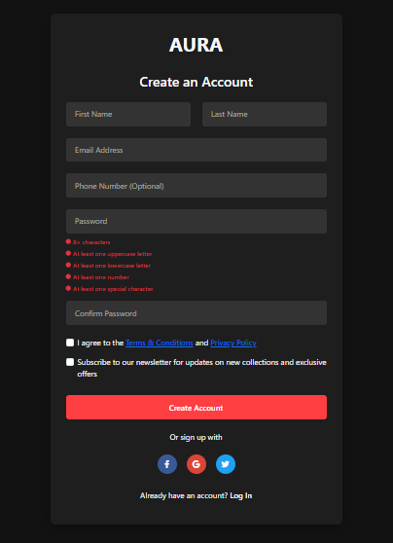

**JavaScript Form Validation:**

**Real-time Feedback**: Visual cues (icons/colors) for password rule (***passwordValidator.js***).

**Custom Validation:** Checks email uniqueness, password match, and required fields (***auth.js, script.js***).

**Error Handling:** Dynamic error messages with icons for invalid inputs (***script.js***).

**Smooth UI Enhancements**

**Smooth Scrolling:** Anchor links animate scroll transitions (***script.js***).

**Navbar Effects:** Background/padding changes on scroll ***(script.js***).

**Dropdown Animation**: Collections menu slides smoothly (***script.js***).

**Final Styling & Enhancements**

**Smooth Transitions & Animations:**

**Dropdown Menu Animation (*script.js*)** :

The Collections dropdown slides smoothly with a 300ms transition when toggled, using custom JavaScript (***classList*** manipulation with ***setTimeout***).



**Smooth Scrolling (*script.js***) :

Anchor links (***e.g., "About," "Contact"***) use ***window.scrollTo({ behavior: 'smooth' })*** for seamless navigation.

**Sticky Navbar & Interactive UI Sticky Navbar :**

The navbar becomes opaque and shrinks on scroll (>50px) for better visibility (***script.js***):



**Interactive Menu Toggle :**

The mobile menu toggles via Bootstrap’s ***data-bs-toggle="collapse"*** and includes a smooth close-on-click-outside feature.(**script.js + Bootstrap**)

**Future Enhancements**

To further improve the website, we plan to integrate **MongoDB** as the backend database to dynamically fetch product images and details. This will enable real-time updates to the shopping cart with automatic price calculation. Additional features will include

***A secure payment gateway*** *for seamless transactions*

***User profile pages*** *to view order history and preferences*

***Product review system*** *for customer feedback*

***Admin dashboard*** *to manage inventory and orders*

These upgrades will enhance functionality, scalability, and user experience while maintaining the existing design.

**Git Hub Repository**

https://github.com/AqibRaza645/Web-Assignement.git

The Contributions of all the team members are shown as commits in this repository also the readme file exclusively explains the contributions of each member as the development of this assignment web application

**Deployed Website**

The Website is Deployed and hosted on GITHUB for which the link is given below:

https://aqibraza645.github.io/Web-Assignement/